Practice this only in Service-Now Demo instance
Assignment
- Create a Catalog item
- Hide ‘Add to Cart’ button ,search ,price ,Quantity in the form
- Add “order now” button

- Create variables with different types like select box, single line text, multiline text, multiple choices, Reference , Date ,etc., and add the values to each variable.

- Create a form with the variables Group, create, created by. Here Group is Reference Field. Group table is reference table for Group.
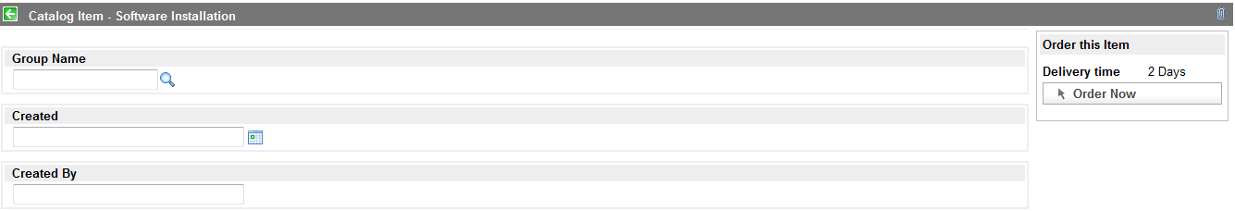

- Write client scripts to populate the value of the variables create and created by in the form while selecting group from Group table.

- Write UI policy, if the group is “Software” then create and created by as mandatory.

- Write Client scripts to update subcategory while selecting values in category field.

For Example: Create category and sub category in the form. Category is Lookup Select Box and Lookup from table is “Incident” table. If you select “software” in category, subcategory value will display depends on category (software). Subcategory will change depends upon the category.

